**Que: Find suitable user guide for installation of Ubuntu for dual boot and single boot?**

Ans:1. **Download Ubuntu:** For you first need to download a Ubuntu ISO CD image file. In this example we install Ubuntu version 15.10. But it does not matter what version you use. It is important that you download the **Desktop** version. If you download the **Server** version it will not install any graphical desktop and you will have to add that manually.

**2. Check if Your Computer will Boot from USB:** Here we provide general guidance and not specific click-here-click-there instructions for BIOS. Most of the time you can bring that up by pressing the **Esc** key when the machine is booting.Before you change any BIOS settings just stick in a bootable USB Ubuntu drive and see if you machine boots from that. If it does fine: proceed with the installation instructions in the next section. If not, continue with these BIOS instructions.

**3. Make BIOS Changes:** You need two things to install Ubuntu from a USB: (1) corrected BIOS settings on your computer to look for an operating system on the USB before it looks to the hard drive for that and (2) a bootable USB (We explain below how to create that.). A bootable USB means one that has a bootable partition on it. In other words you cannot simply copy the Ubuntu ISO to the USB. It needs to be burned on with a tool like Unetbootin, which you can get from here.Once you figure out how to bring up the BIOS boot settings, change the UEFI Boot Order to put USB at the top of the list ahead of OS Boot Manager. If you have Legacy Support enabled then you change the Legacy Support Boot Order instead.

**4. Try Ubuntu Before you Install It:**

If you want to try Ubuntu before installing that you can run it from the USB drive using UnetBootin (Which we use in the next section to create the bootable USB). Also the Ubuntu installation screens will give you that option too.

**5. Create Bootable USB:** Download and install UNetbootin and use that to create a bootable USB. This will create a bootable partition on the disk and copy Ubuntu there. Trying to make a bootable USB drive yourself is otherwise complicated.

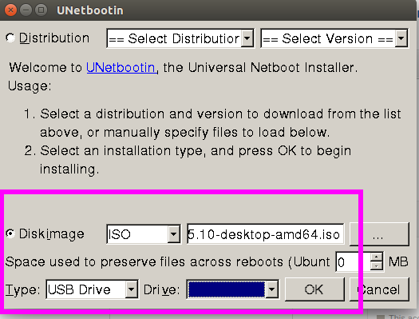

Enter the location of the ISO file that you downloaded and select the USB drive letter or location.

**6. Install Ubuntu:**

Once you get the bootable USB working follow the screens below to install USB:

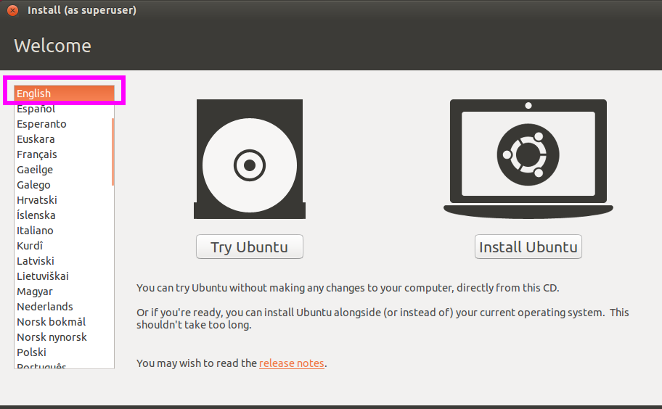

Pick your language.

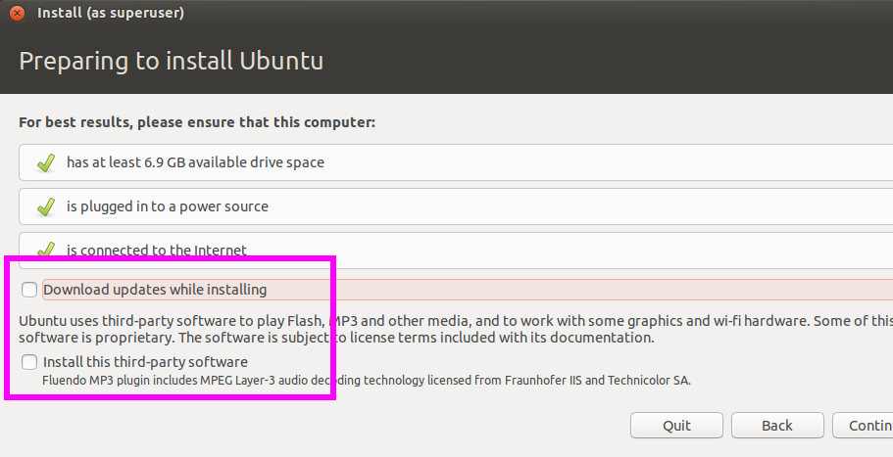

Here click Download Updates while Installing and Install This Third-Party Software. Either way Ubuntu will download the bulk of the operating system from the internet. Look at the next graphic for an explanation.

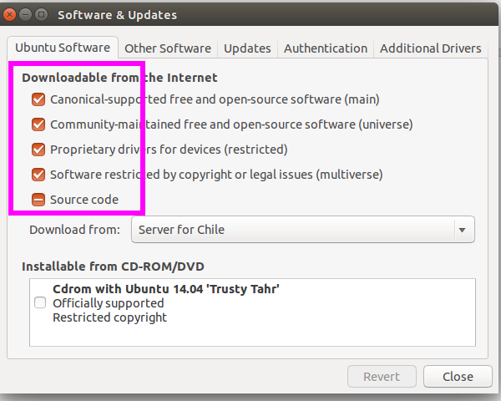

If you select the download and 3rd party options above then Ubuntu will update the repository, which is the list of servers from which it will download software. You can see those options in the Software and Updates screen after you have completed installing Ubuntu. You can go back later and add those that after the installation if you want.

Notice that in this screen it lists CD as an option. Unselect that as otherwise it will prompt you to plug in the USB after you have Ubuntu running.

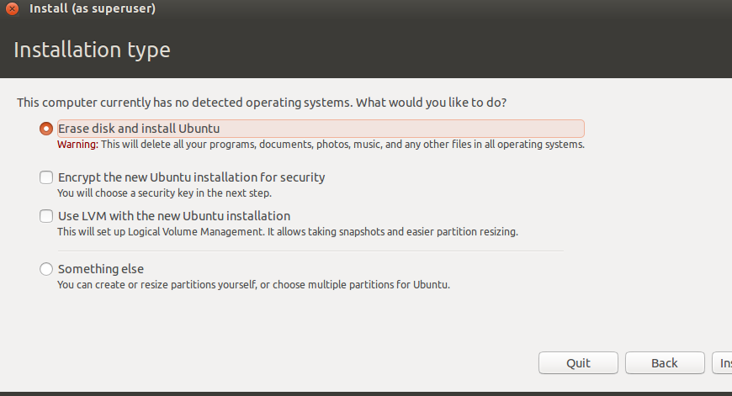

Select Erase disk and install Ubuntu. The Something else option would let you create your own partitions, which would be complicated, which you could do if you want to have a dual boot machine to be able run Windows or Ubuntu on the same machine.

But there is no need to deal with that complexity as you can run Ubuntu in a virtual machine as we explain below. The Something else would also let you pick the second, solid state drive in your laptop or desktop to install Ubuntu, but that is a more complicated installation. Plus if you mess that up you can end up with a machine that will not boot at all.

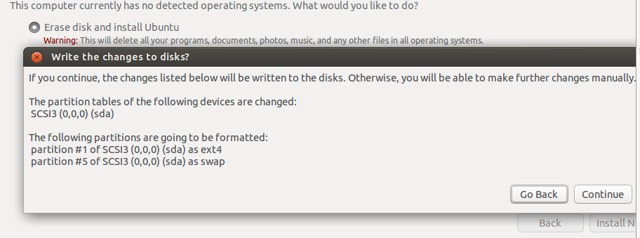

Click continue to commit to erasing the existing partitions on your hard disk.

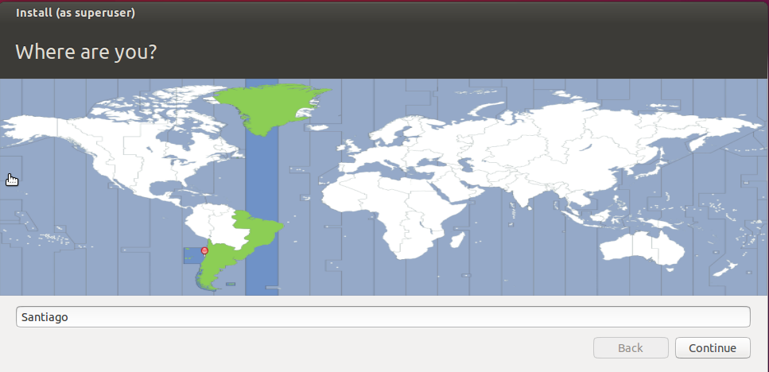

Select the time zone.

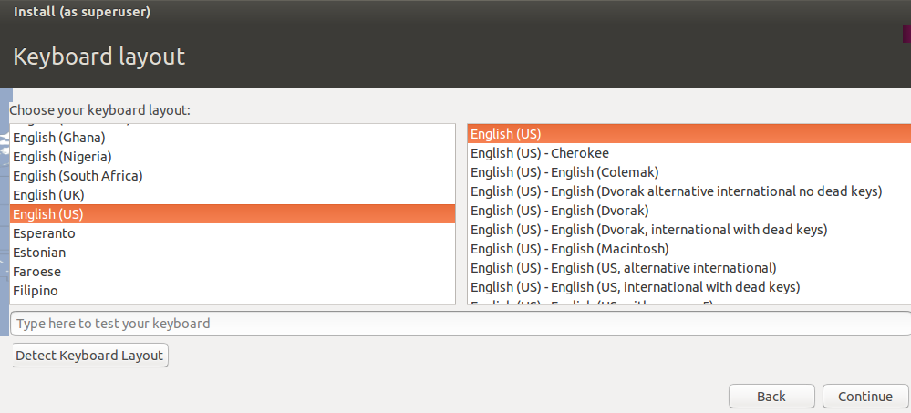

Pick the keyboard type.

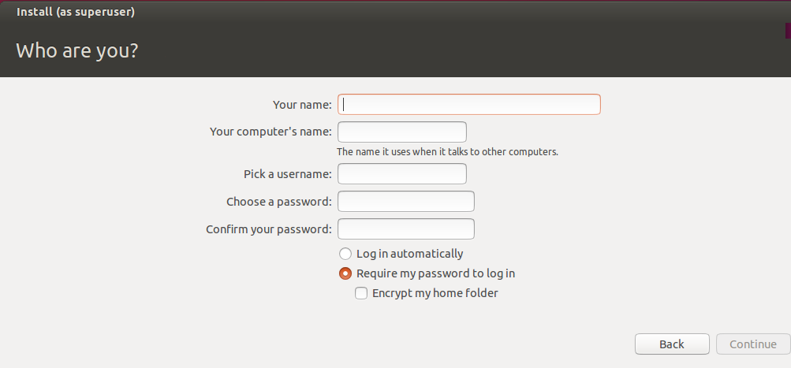

Create a username, password, and computer name. You will login with this userid after the installation is complete.

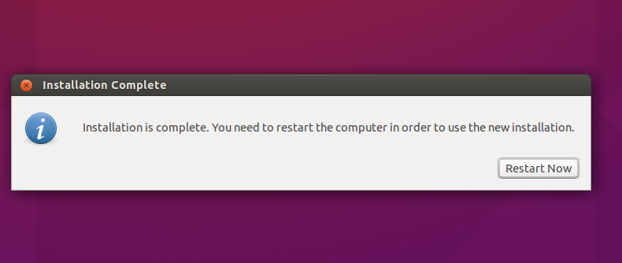

Now the installation is complete. Remove the USB drive and click Restart Now. If you have installed Ubuntu into a virtual machine, the Restart Now option will probably give an error message, so use the virtual machine software to restart the machine instead of here.

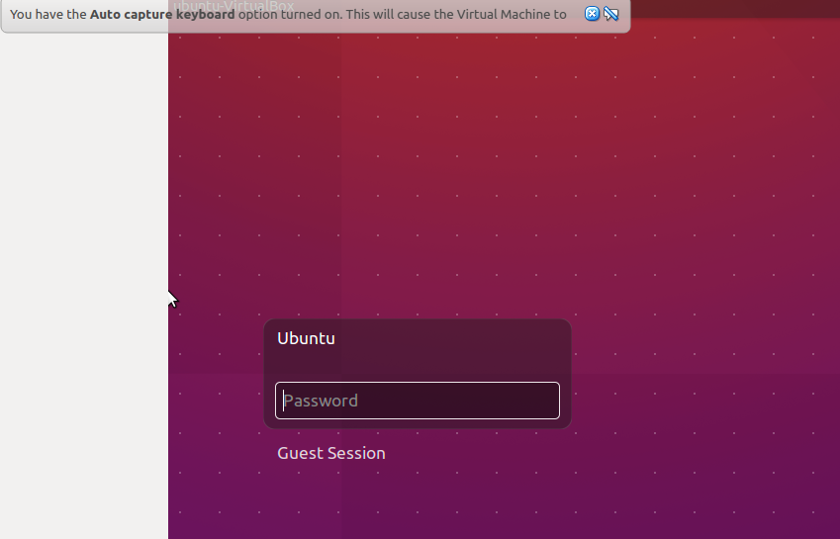

Now login with the user id you created.